# CSS Syntax

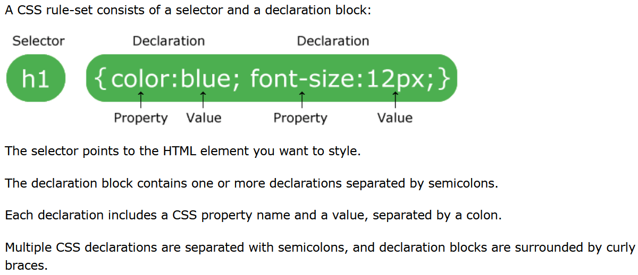

# CSS Backgrounds

## Background-color

**background-color: lightblue;**

*Reference:* [*https://www.w3schools.com/cssref/pr_background-color.asp*](https://www.w3schools.com/cssref/pr_background-color.asp)

## Opacity/Transparency

**opacity: 0.3;**

*Reference:* [*https://www.w3schools.com/cssref/css3_pr_opacity.asp*](https://www.w3schools.com/cssref/css3_pr_opacity.asp)

## Background-image

**background-image: url(“paper.gif”);**

*Reference:* [*https://www.w3schools.com/cssref/pr_background-image.asp*](https://www.w3schools.com/cssref/pr_background-image.asp)

## Background-repeat

**background-repeat: repeat-x;**

*Reference:* [*https://www.w3schools.com/cssref/pr_background-repeat.asp*](https://www.w3schools.com/cssref/pr_background-repeat.asp)

## Background-position

**background-position: right top;**

*Reference:* [*https://www.w3schools.com/cssref/pr_background-position.asp*](https://www.w3schools.com/cssref/pr_background-position.asp)

## Background-attachment

**background-attachment: fixed;**

*Reference:* [*https://www.w3schools.com/cssref/pr_background-attachment.asp*](https://www.w3schools.com/cssref/pr_background-attachment.asp)

## Background Shorthand Property

**background: #ffffff url(“paper.gif”) no-repeat right top;**

*Reference:* [*https://www.w3schools.com/cssref/css3_pr_background.asp*](https://www.w3schools.com/cssref/css3_pr_background.asp)

# CSS Fonts

## Font-family

**font-family: “Times New Roman”, Times, serif;**

*Reference:* [*https://www.w3schools.com/cssref/pr_font_font-family.asp*](https://www.w3schools.com/cssref/pr_font_font-family.asp)

## Font-style

**font-style: normal;**

*Reference:* [*https://www.w3schools.com/cssref/pr_font_font-style.asp*](https://www.w3schools.com/cssref/pr_font_font-style.asp)

## Font-weight

**font-weight: bold;**

*Reference:* [*https://www.w3schools.com/cssref/pr_font_weight.asp*](https://www.w3schools.com/cssref/pr_font_weight.asp)

## Font-variant

**font-variant: small-caps;**

*Reference:* [*https://www.w3schools.com/cssref/pr_font_font-variant.asp*](https://www.w3schools.com/cssref/pr_font_font-variant.asp)

## Font-size

**font-size: 40px;**

*Reference:* [*https://www.w3schools.com/cssref/pr_font_font-size.asp*](https://www.w3schools.com/cssref/pr_font_font-size.asp)

## Font Shorthand Property

**font: italic bold 12px/30px Georgia, serif;**

*Reference:* [*https://www.w3schools.com/cssref/pr_font_font.asp*](https://www.w3schools.com/cssref/pr_font_font.asp)

# CSS Text

## Color

**color: blue;**

*Reference:* [*https://www.w3schools.com/cssref/pr_text_color.asp*](https://www.w3schools.com/cssref/pr_text_color.asp)

## Background-color

**background-color: lightgrey;**

*Reference:* [*https://www.w3schools.com/cssref/pr_background-color.asp*](https://www.w3schools.com/cssref/pr_background-color.asp)

## Text-alignment

**text-align: center;**

*Reference:* [*https://www.w3schools.com/cssref/pr_text_text-align.asp*](https://www.w3schools.com/cssref/pr_text_text-align.asp)

## Vertical-align

**vertical-align: top;**

*Reference:* [*https://www.w3schools.com/cssref/pr_pos_vertical-align.asp*](https://www.w3schools.com/cssref/pr_pos_vertical-align.asp)

## Text-decoration

**text-decoration: overline;**

*Reference:* [*https://www.w3schools.com/cssref/pr_text_text-decoration.asp*](https://www.w3schools.com/cssref/pr_text_text-decoration.asp)

## Text-transformation

**text-transform: uppercase;**

*Reference:* [*https://www.w3schools.com/cssref/pr_text_text-transform.asp*](https://www.w3schools.com/cssref/pr_text_text-transform.asp)

## Text-shadow

**text-shadow: 2px 2px 5px red;**

*Reference:* [*https://www.w3schools.com/cssref/css3_pr_text-shadow.asp*](https://www.w3schools.com/cssref/css3_pr_text-shadow.asp)

# CSS Box Model



# CSS Borders

## Border Shorthand Property

**border: 5px solid red;**

*Reference:* [*https://www.w3schools.com/cssref/pr_border.asp*](https://www.w3schools.com/cssref/pr_border.asp)

# CSS Margins

## Margin Shorthand Property

**margin: 25px 50px 75px 100px;**

*Reference:* [*https://www.w3schools.com/cssref/pr_margin.asp*](https://www.w3schools.com/cssref/pr_margin.asp)

# CSS Padding

## Padding Shorthand Property

**padding: 25px 50px 75px 100px;**

*Reference:* [*https://www.w3schools.com/cssref/pr_padding.asp*](https://www.w3schools.com/cssref/pr_padding.asp)

## Box-sizing

**box-sizing: border-box;**

*Reference:* [*https://www.w3schools.com/cssref/css3_pr_box-sizing.asp*](https://www.w3schools.com/cssref/css3_pr_box-sizing.asp)